Geometry – A Tale of Two Quizzes
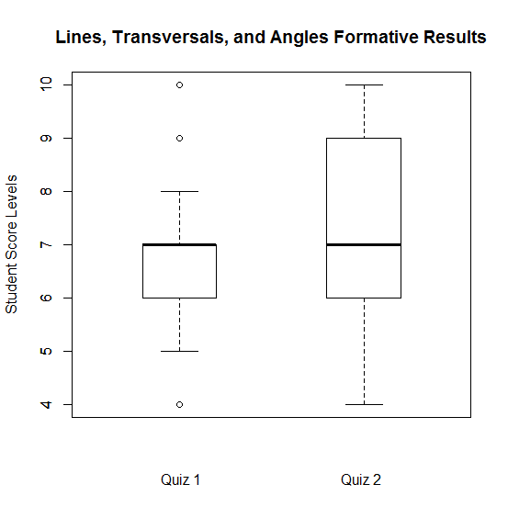
“It was the best of times, it was the worst of times…” – Not really, we just started learning this stuff

In the boxplot above, as really should be done in all boxplots, values (the 4’s, 9’s, and 10’s on Quiz 1) that are extremely different than the rest of the group are shown as individual values.
- Write a statement or two comparing the median score of students on the two quizzes. Your statement(s) should interpret this measure of knowledge in the context of the rubric.

- Consider overall range, compare the range of scores on quiz 1 and quiz 2, both with and without the outliers included. If an outlier greatly changes our description, then it should be considered influential. Would you consider any outliers to be influential? If so, which ones?

- In which class was their more variation among the ‘average students’? In the context of the rubric, would you consider this a good thing or a bad thing? Explain.

